1. Install anaconda navigator https://docs.anaconda.com/anaconda/install/
2. Run anaconda, and launch jupyter notebook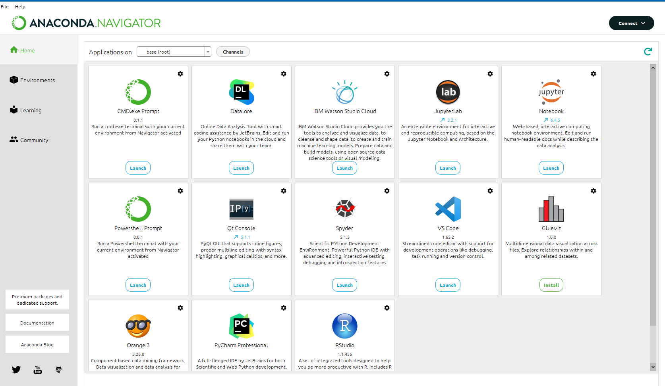
3. You will be redirected to a new page on the web browser by anaconda to view the jupyter notebook page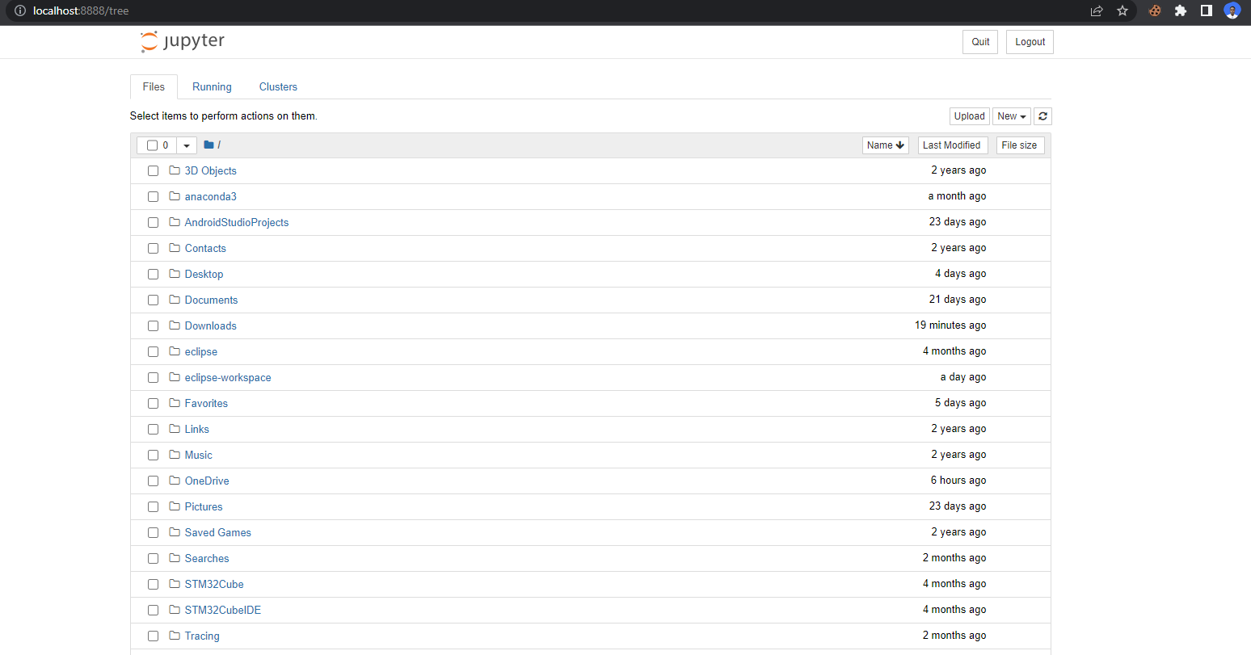
4. On the navigation menu you will find an upload button
5. click on the upload button and select the rainfallprediction.ipynb and the india.csv files and upload
6. confirm upload
7. once uploaded locate the files on the display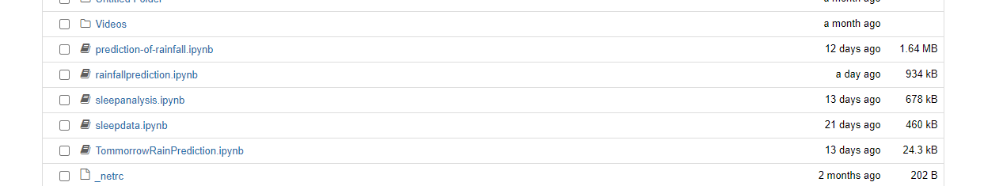
8. Click on our .ipynb file to run it
9. A new page will be opened where you can run the python code

